
Year 9 - Design a backyard Investigation.

Name _____________________

Students are permitted
1 A4 page of handwritten notes (back and front)
1 calculator, pens and rulers

  - Time permitted: 50 minutes Score: ________ / 45
Joffrey and Sansa have decided to redesign their backyard. The basic layout is a rectangle with a rectangular pool as shown below.
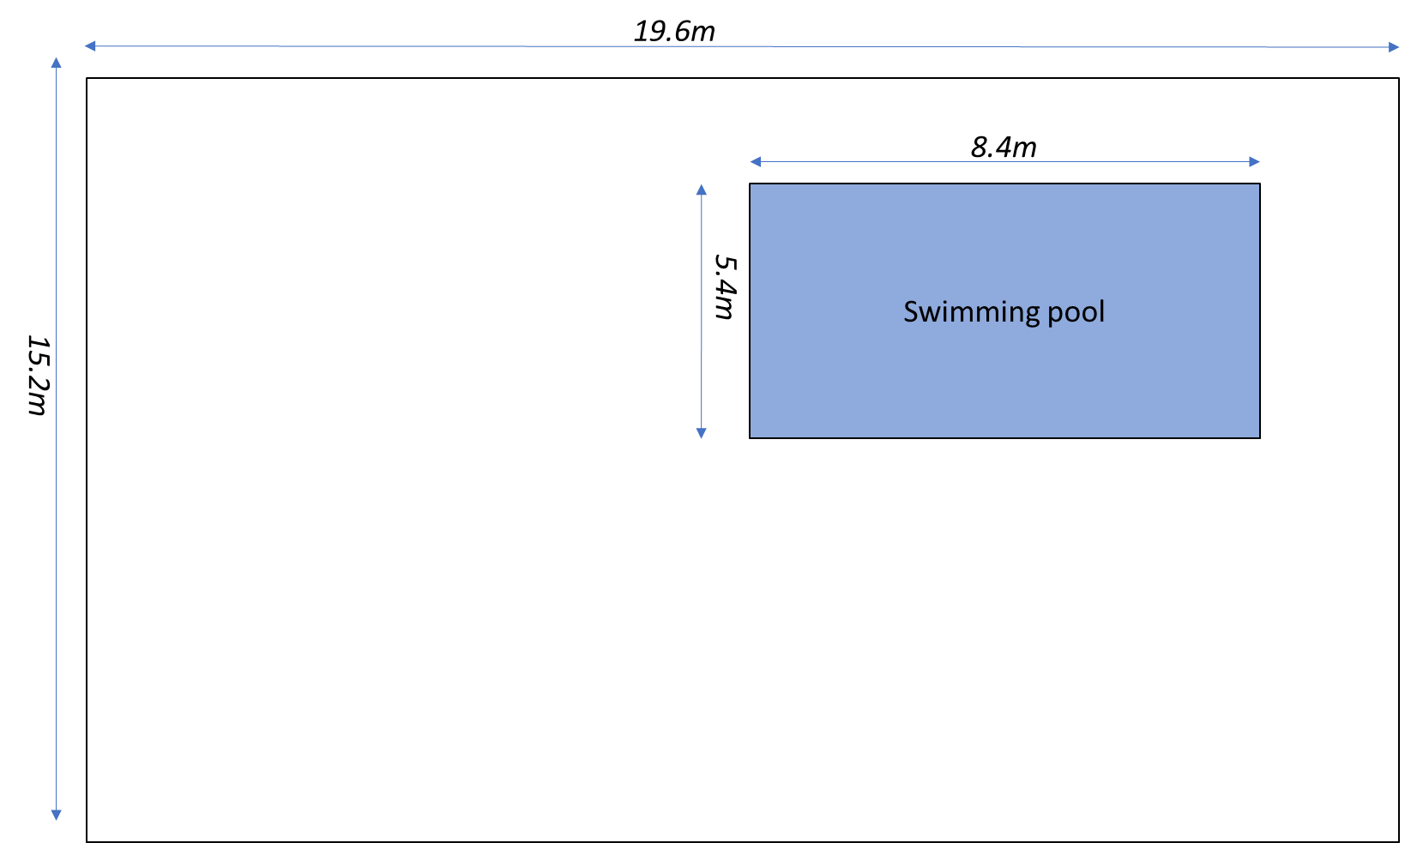

Question 1. What Is the total area of the entire backyard? (2 marks)

Question 2 . If the pool is 5.4m wide and 8.4m long, how much area does the pool occupy? (2 marks)

They have had a landscaping company create a design for their backyard
Design by Littlefinger’s Clever Designs
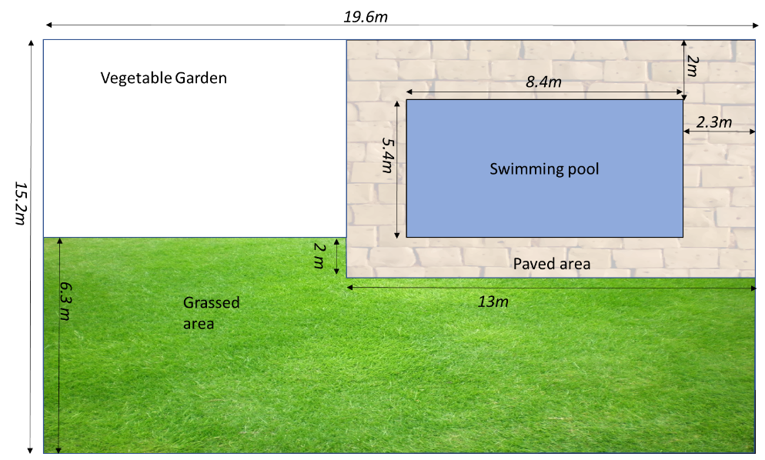
Question 3: What is the area of the grassed patch? (3 Marks)

Question 4: What is the total area for the vegetable garden? (3 Marks)

Question 5: How many square metres of paving will be required? (4 Marks)

Question 6: A reticulation pipe needs to be run around the garden and the grass. What is the length of the perimeter of the grass and the vegetable garden if they are combined into a single shape. (3 Marks)

Question 7: Part of the redesign of the backyard involves repainting the concrete pool. The pool is unusual as it is a rectangular prism and has a constant depth of 1.8m for its entire length. Calculate the surface area of the pool that needs to be repainted (remember the pool is open on top and so the top of the prism does not need to be painted). (6 Marks)
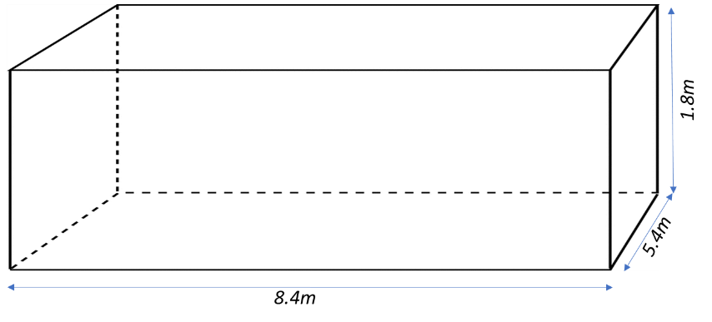

Question 8: Jothrey’s uncle has offered to buy a water tank for the couple so they can have clean rainwater to drink. There are 2 options for the rainwater tank. Calculate the surface area for both. (6 Marks)
Question 8: Part A Option 1 is a right angled triangular prism with a lid.
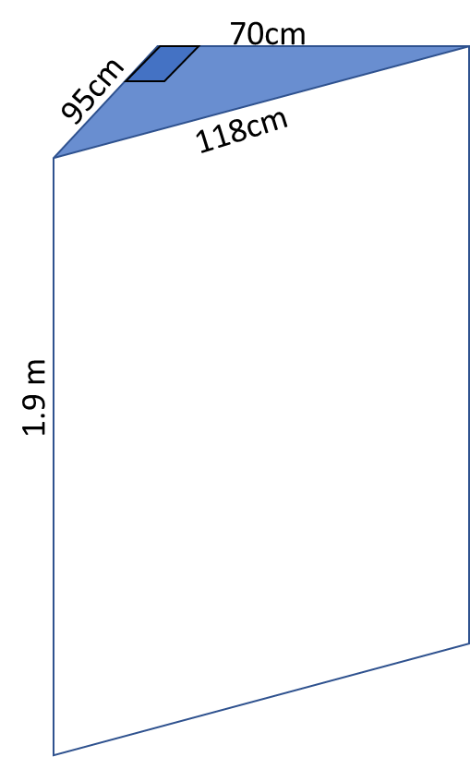

Question 8: Part B Option 2 is a cylinder (also with a lid) and has a radius of 0.8m and a height of 1.8m. (6 Marks)
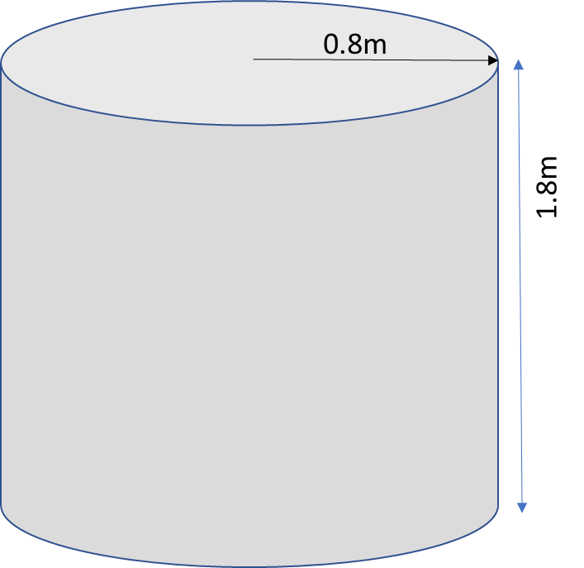

Question 8: Part C To keep the cost down, they want to use the water tank that uses the least amount of material to make. Which tank should they use and why? (2 Marks)

Question 9: Joffrey has also had a small shed delivered so he can safely store some sharp implements. The shed is delivered in pieces and he needs to assemble it.
Question 9: Part A Based on the net below, sketch the shed and label it with the lengths of all the sides (2 Marks)
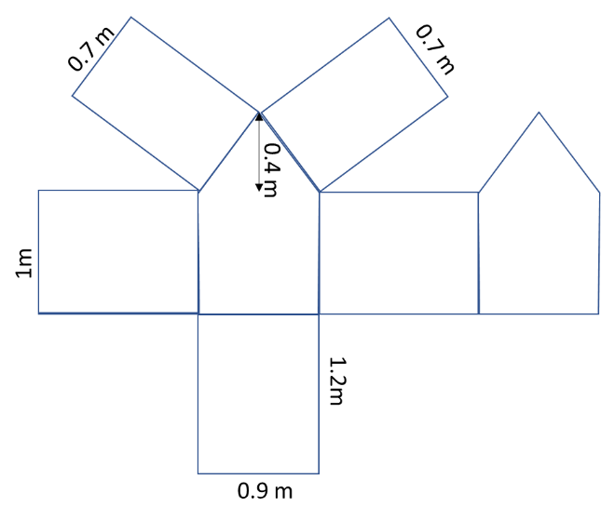
Question 9: Part B To help hide any stains, Joffrey wants to paint the inside of the shed including the floor bright red. Calculate the surface area of the shed so Joffrey knows how much paint to order. (6 marks)

End of Investigation.

